**Activity 9 : Backend**

|  |  |
| --- | --- |
| Group # |  |

Participating group members

|  |  |
| --- | --- |
| Student ID | Name |
|  |  |
|  |  |
|  |  |

# Synopsis

Here is a list of what you are expected to have already learned from the preparation.

* + How to start a Firebase project
  + How to create a Firestore in the project
  + How to setup a Firestore in the project
  + How to connect Firestore to a frontend application
  + How to do CREATE, DELETE, and GET data to/from database
  + All these in your last project!

In the activity, you will:

* + Learn some Javascript concepts used in the starter project
  + Try to implement it to the Frontend Web Application

# Activity time table

|  |  |
| --- | --- |
| Time | Activities |
| 9:30 - 10:00 | Activity briefing, Attendance checking (at 9:45) |
| 10:00 - 12.20 | Working in groups (Part A, Part B, Part C, Outstanding) |
| 12:20 - 12:30 | Activity debrief |

# Part A: Setup a Firestore Collection

* Setup your Firestore to store **Documents** of items to buy
* Add a new **Collection** in you Firestore

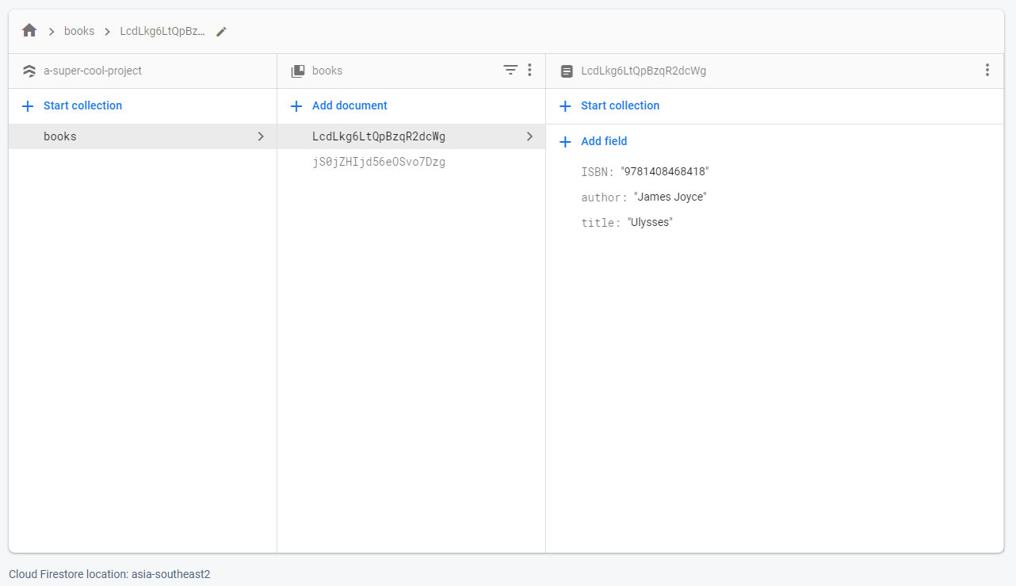

Fig. 1 Firestore page that you will add a new Collection of items to buy

|  |
| --- |
| What is the structure of a Document that represents an item to buy |
|  |

|  |
| --- |
| Show a screenshot of a Firestore page with your new Collection |
|  |

# Part B: Connecting Firebase to the Web App

* Connect your Firebase project to the Web App

|  |
| --- |
| Show a screenshot of how you did that |
|  |

# Part C: Sync Firestore to the Web App

* (i) The items shown in the table should come from the items in Firestore
* (ii) Adding a new item in the table should also add that item to the Firestore
* (iii) Removing an item in the table should also remove that item in the Firestore
* [See this sample of the end result](https://youtu.be/oMOgb8tryXk)

|  |
| --- |
| Useful JavaScript How-to  * [Creating and triggering events](https://developer.mozilla.org/en-US/docs/Web/Guide/Events/Creating_and_triggering_events)   + window.document.dispatchEvent   + document.addEventListener |

You can do (i), (ii), (iii) with your own methods, but this snippet code may be useful

const items_ref = db.collection('{???????????}');

async function showItemsInTable() {

const table_body = document.getElementById('main-table-body')

table_body.innerHTML = ''

const collection = '{???????????}'

const items = '{???????????}'

items.map((item) => {

table_body.innerHTML += `

<tr id="${item.docId}">

<td>${'{???????????}'}</td>

<td>${'{???????????}'}</td>

<td>${'{???????????}'}</td>

<td><button class="delete-row" onclick="deleteItem('${item.docId}')">ลบ</button></td>

</tr>

`

})

}

document.addEventListener("DOMContentLoaded", function(event) {

console.log('showing items from database')

showItemsInTable()

});

function redrawDOM() {

window.document.dispatchEvent(new Event("DOMContentLoaded", {

bubbles: true,

cancelable: true

}));

document.getElementById("item-to-add").value = "";

document.getElementById("name-to-add").value = "0";

document.getElementById("price-to-add").value = "";

}

async function addItem() {

}

var addButton = document.querySelector("#add-newrow");

addButton.onclick = async () => {

addItem().then(() => {

redrawDOM()

})

}

async function deleteItem(docId) {

}

|  |
| --- |
| Describe your code how to do (i) |
|  |

|  |
| --- |
| Describe your code how to do (ii) |
|  |

|  |
| --- |
| Describe your code how to do (iii) |
|  |

* ส่งงาน Part A, B, C ใน Activity 9: Submission ภายใน 12:20
  + ส่งไฟล์ Worksheet นี้ในรูปแบบ PDF โดยแนบไปยัง Attachment Slot ชื่อ Worksheet PDF
  + Zip โฟลเดอร์และส่งไฟล์ Zip โดยแนบไปยัง Attachment Slot ชื่อ Zipped Folder for Part A to C

# Outstanding Factor

* ทำส่วนนี้เพื่อรับการพิจารณา Outstanding Factor สำหรับกิจกรรมนี้ โดยเลือกทำอย่างใดอย่างหนึ่งระหว่าง

|  |
| --- |
| Host your frontend at the [Firebase Hosting](https://firebase.google.com/products/hosting), you will need to download [NodeJS](https://nodejs.org/en/download/) to be able to use *npm* |
| ***A Link to Your Website*** |

หรือ

|  |
| --- |
| Add Update functionality to the Frontend |
| ***Describe your code how to do it*** |

* ส่งงานเพื่อ Outstanding Factor ใน Activity 9: Submission ภายใน 12:20
  + Zip โฟลเดอร์และส่งไฟล์ Zip โดยแนบไปยัง Attachment Slot ชื่อ Zipped Folder for Outstanding Factor